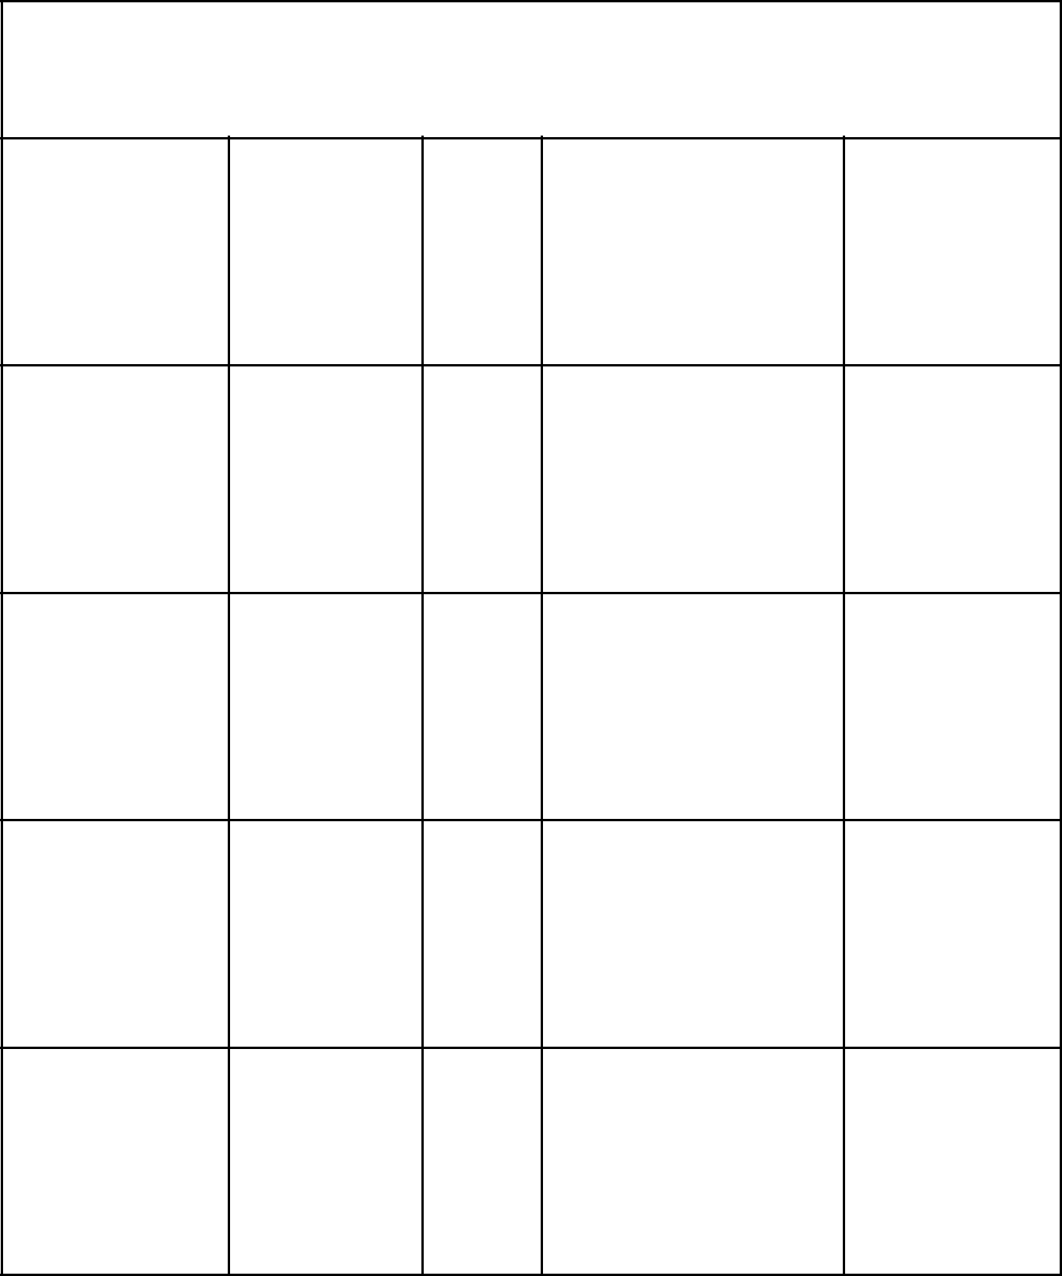**Schechter Experiences Bingo**

The

Joseph Play Graduation Pizza Hot Lunch Science

Eater

|  |  |  |
| --- | --- | --- |
| Chromebook |  | Go |
| Jail | Speak | Lions! schechtermemes1 World Wars |

|  |  |  |  |  |  |
| --- | --- | --- | --- | --- | --- |
| Kindergarten | Alternative **FREE** | | Gym | Yom |  |
| Israel | **Free** | Ha’Atzmaut |  |
|  | **Space** |  |  |
|  |  |  |  |  |

|  |  |  |  |
| --- | --- | --- | --- |
| B’nai | TKAMB Night Yom Ha’Shoah | Touching |  |
| Mitzvahs | The Lights |  |

|  |  |  |
| --- | --- | --- |
| Chemistry Coach T.J LA | Coach Doug | 8th Grade |